TI 23 – 15 Technology Example – INTOG
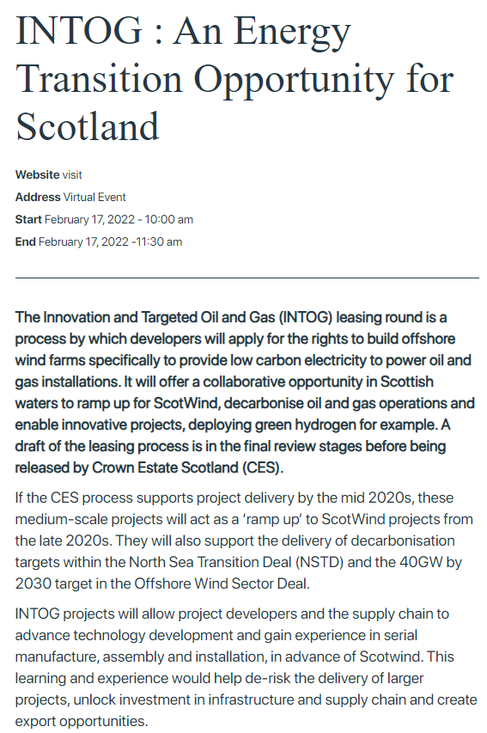
Link to website:
INTOG : An Energy Transition Opportunity for Scotland - ORE (catapult.org.uk)

